Summer Street Industries tackles inclusivity and food insecurity
Sarah Jordan | Posted: 20 hours ago | Updated: 4 hours ago | 3 Min Read

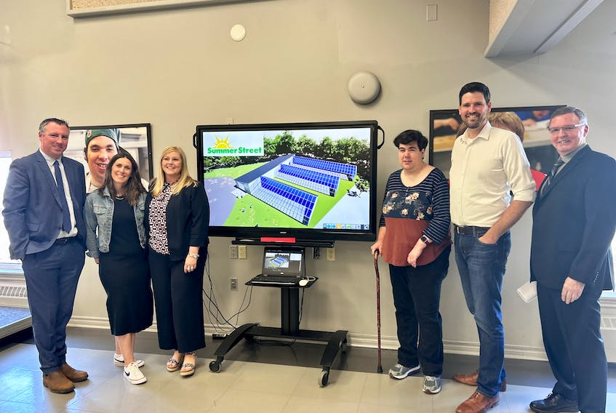From left to right: Greg Morrow, Rae Dunn, Karla MacFarlane, Tracy Hermillon, Sean Fraser and Keith Appleton next to a rendering of what the new greenhouse facility will look like. - Sarah Jordan
STORY CONTINUES BELOW THESE SALTWIRE VIDEOS
NEW GLASGOW - Central Nova MP Sean Fraser announced Tuesday that Ottawa is putting $1.5 million into a new three-bay all-season greenhouse at Summer Street Industries in New Glasgow.
The money comes from Canada Coal Transition Initiative-Infrastructure Fund.
The province is providing another $1.4 million, from two departments to the organization which employs adults with intellectual disabilities.
Provincial agriculture minister Greg Morrow says the money will help Summer Street extend the growing season which helps with its catering operation.
“We talk a lot about food security today, increasing local food production and this project accomplishes that,” Morrow said.
Morrow has a personal connection, as well. His brother worked at a similar facility.
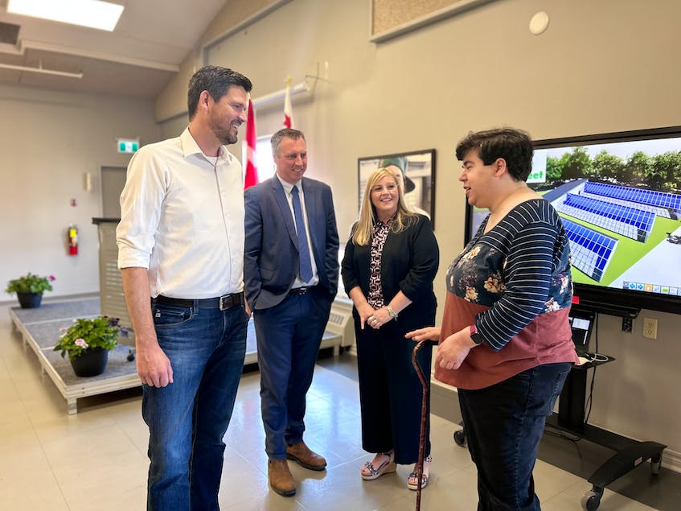Sean Fraser, Greg Morrow, and Karla MacFarlane chatting with Tracy Hamilton after the announcement. - Sarah Jordan

Quick facts:

-Summer Street Industries employs over 180 adults with intellectual disabilities

-The new greenhouse will be more than 325 square metres.

-It will meet the Rick Hansen Foundation accessibility standards.
Tracy Hermillon, who has been with Summer Street for more than a decade, thanked Fraser, Morrow, and
Karla MacFarlane, MLA for Pictou West for “Helping make Pictou County a better community.”
Hermillon shared her enthusiasm about the new facility. “We’ll now have a new opportunity that people are interested in.”
The project will help strengthen local food systems, such as the food bank and the well-known catering service Summer Street Industries provides to the community.
“Today is an awesome day,” MP Fraser said.
“We’ve been working with Summer Street on this project for a few years now. I initially funded the feasibility study, but seeing the work that the staff and participants at Summer Street have put in has led to a nearly $3-million project. This is going to help grow food locally, but it's going to create meaningful paid work for adults with intellectual disabilities in our community.”
The new greenhouse facility will create jobs for participants of Summer Street Industries, as well as teach them hands-on gardening skills and create relationships with local farmers and businesses.
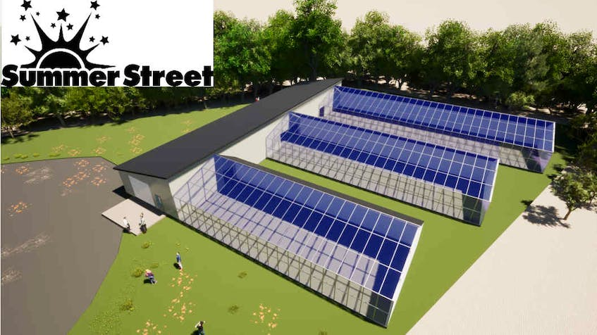Rendering of the three-bay greenhouse to be built by Summer Street Industries in New Glasgow - Contributed
MLA MacFarlane said it’s the collaboration that is important. “There’s just so many diverse groups involved in this. And at the end of the day, we just know that this is going to be a huge positive economic impact on the community.”
Construction is set to begin this spring, and Summer Street hopes that it will be open and operational this winter.

