For IMMEDIATE RELEASE

Pls contact Bob Bennett 902-759-6693 bob@summerstreet.ca

Summer Street's Approach to Leadership: Prioritising Participant Voices

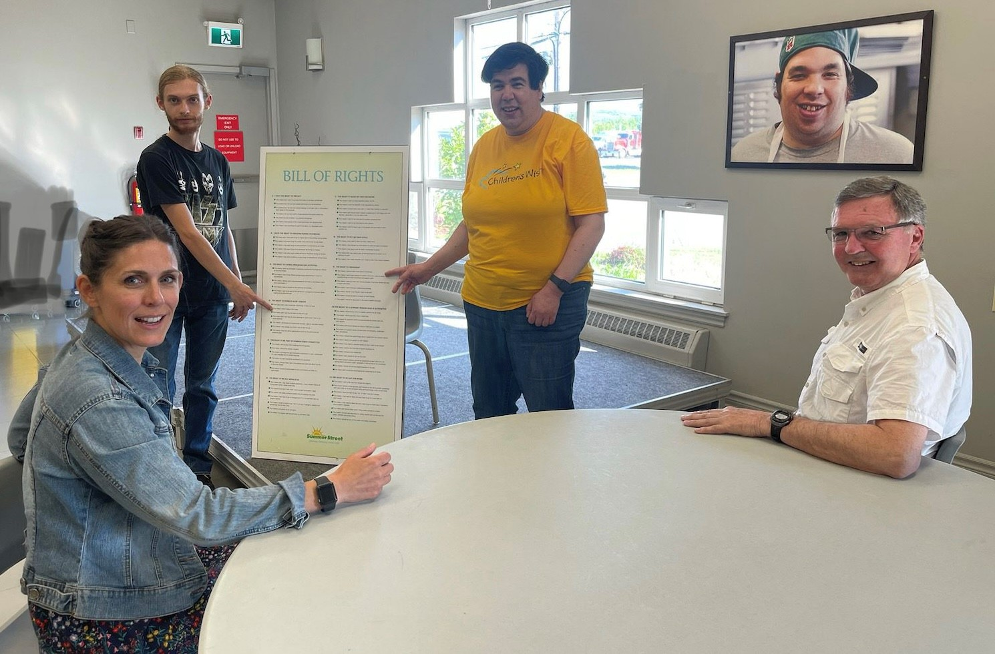
Rae Gunn, Storm Smith, Tracy Hermillon, Keith Appleton

By Miranda Bowron

Summer Street takes a unique approach to leadership, placing its participants at the apex of its organisation. This model of leadership means that participants' voices are not only heard, but prioritised and valued. Summer Street's Participant Council was established in 2009 to ensure that participants were involved in the process of organizational changes. Summer Street's Bill of Rights is a guiding light for the organization, ensuring that participants' needs are being met and respected. Each year, the Participant Council reviews Summer Streets' Bill of Rights and they discuss the areas in which they'd like to see improvement. The feedback provided by the Participant Council empowers the organisation to make decisions that benefit participants, staff, and the community as a whole.

I had the opportunity to speak with two members of the participant council, Storm Smith (President) and Tracy Hermillon (Secretary). The Participant Council is involved in all aspects of the organisation, including having representation on the Equity, Diversity, Inclusion & Accessibility Committee, Strategic Planning Committee and are actively involved in new project analysis and Summer Street's hiring process. When asked about the areas in the Bill of Rights in which they would like to see improvement, Storm and Tracy both agreed that they would like to see Summer Street continue to create additional training and employment opportunities for its participants. Currently over 50% of the Summer Street workforce have diverse abilities! Tracy, who currently takes a number of courses at Summer Street, would love to see additional training courses that reflect participants' unique skill sets and interests. "Through my time at Summer Street, I have learned skills related to self-advocacy, and I feel like I can be a voice for others," said Hermillon. "Participants have the opportunity to sit in on interviews" said Smith, who described being involved in Summer Street's hiring process. Participants' opinions are highly valued in the interview process, and the Bill of Rights is an important tool to ensure potential candidates understand Summer Streets' values and mission. Storm and Tracy both expressed their appreciation for the Participant Council and Summer Street's Leadership Model which prioritises participants' voices in organizational decisions.
Another key aspect of Summer Street's leadership team is their Society Board, which works closely with Executive Director, Bob Bennett, to set strategic objectives for the organization. The Society Board also works with the Participant Council to ensure that participants' needs are being met. I spoke with Outgoing Board Chair, Rae Gunn, and Incoming Chair, Keith Appleton about their experiences with Summer Street and its unique approach to leadership. According to Keith, 'the participant council is an experience of empowerment for both the participants and the board." Every year the Participant Council reviews and scores Summer Street's organizational performances and their report directly influences key operational strategies moving forward. The board receives feedback directly from participants, allowing them to make decisions that benefit the organization as a whole. Rae Gunn has thoroughly enjoyed her time on the Summer Street Board, and leaves this position speaking highly of the evolution of the Participant Council. The Participant Council was established in 2009, and has continued to grow and inform important decisions at Summer Street. "There is a major project [Summer Street Greenhouse] that will benefit participants and serve the community at large," said Gunn. This project, which the Participant Council, Society Board, and Staff are all helping to develop, will create more job opportunities within Summer Street, and will offer a desired service to community members in Pictou County. These developments happening at Summer Street are a testament to the strength of its leadership model, and how participants' voices are the key to positive organizational growth.
Summer Street's participant-led leadership model has solidified its place as an organisational role model. When asked about the impact of the Participant Council on Summer Street as a whole, Executive Director, Bob Bennett said, " The Participant Council makes sure staff, management and Society Board understand their priorities. Although we are proud of how far we have come, we continue to be open to learning new ways to support our participants to recognize the power they have in shaping their own lives. Sharing decision making power with our participants is one of the best things we have done as an organization." Through their Social Enterprises which connect participants to the community, Summer Street has become the place to go for services such as banquets and catering, trophy and awards engraving and as a source for labour for other employers who regularly hire employees through Summer Streets' Employment Service. According to Keith Appleton, "If you want something done, go to Summer Street." Summer Street values the people at its core, and utilises their feedback to enact changes that benefit the organisation, and the community, as a whole.

